This event brings together the top athletes from across Canada in the novice, junior high performance, junior open, senior high performance and senior open categories in women’s rhythmic gymnastics. Throughout the weekend there will be a total of 30 medal events, and a Canadian Championship titleholder named in each category.
When : May 17-20th
Where : Richmond Olympic Oval, 6111 River Rd, Richmond, BC V7C 0A2
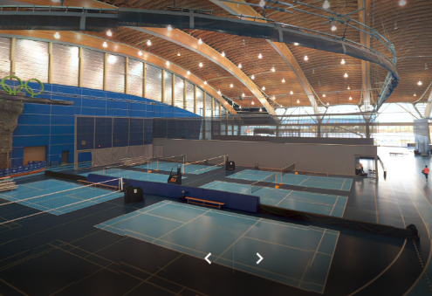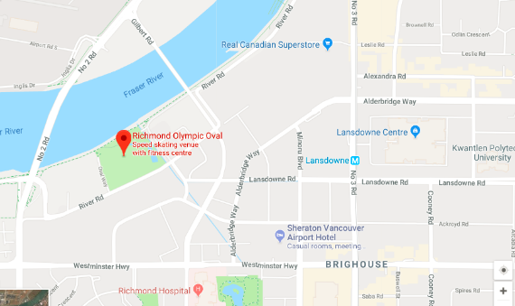
Host Hotel:Hilton Vancouver Airport Hotel, 5911 Minory Boulevard, Richmond BC
Host by: Gymnastics Canada Gymnastique and BCRSGF
- Directive
- Registration Form
Live stream coming on May 16th
Live results coming on Mat 16th

