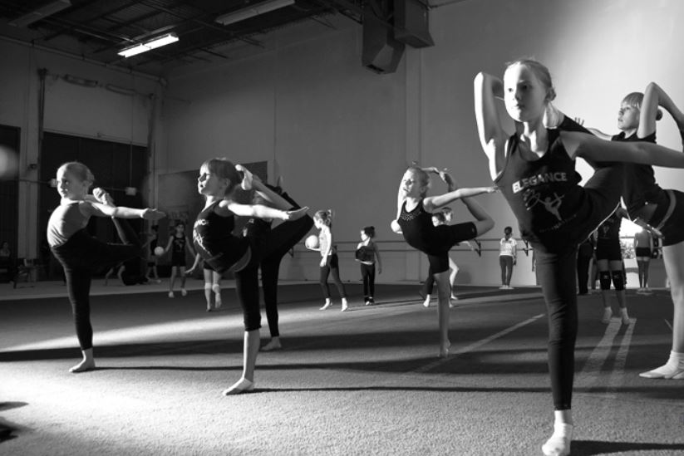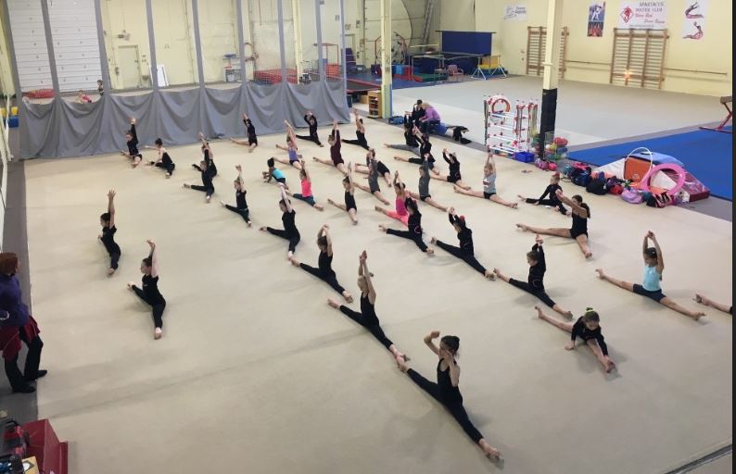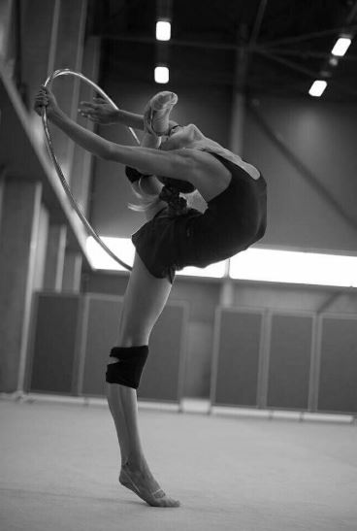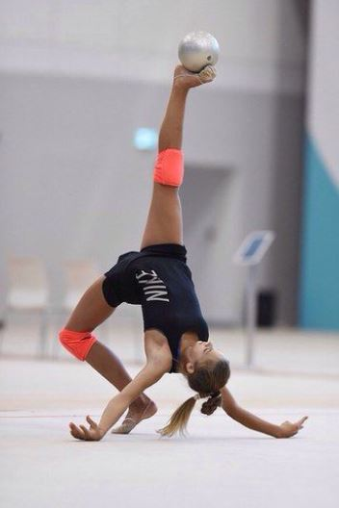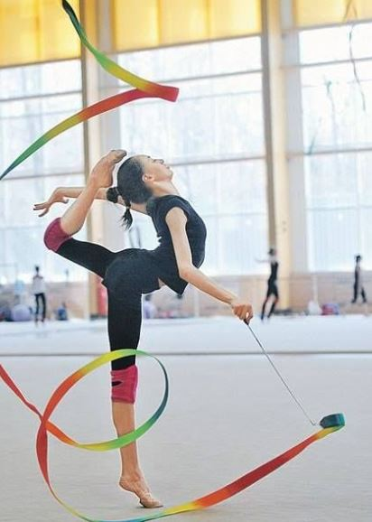

BC Rhythmic Gymnastics Sportive Federation
Return to Play Phase 2 update June 16th

BCRSGF Original Return to Sport (RTS) document was published on May 25, 2020 and was approved by the BCRSGF Board of Directors on May 24, 2020. The BCRSGF Return to Sport document has been updated multiple times since the original publication date.
The most recent update is June 15, 2021 guided by the Government of BC’s Gathering and Events Order– as a part of the Government of BC’s Restart Plan, Step 2. Please note that these updates may only be in place for a short period of time as the Government of BC is looking to progress to Step 3 of the Restart Plan as soon as July 1, 2021. A large amount of the requirements has been modified in this Restart Plan. Please review the entire document and update your club’s Safety Plan accordingly.
Information and graphics describing the BC Restart Plan are available here. viaSport’s Information and FAQs about the Sport Sector is available here.
Key Requirements and Changes for Indoor Sporting Activities as of June 15th, 2021 for Step 2 of the BC Restart Plan Include:
• Recreational Travel is allowed within BC, including for Sport.
• No physical distancing is required on the field of play for indoor sports.
• A maximum of 50 individuals (including coaches, athletes, managers, etc.) can be in one gym space (separate area) at one time.
• Physical distancing of 2 Metres is required to be maintained by all individuals outside of the field of play, unless seated.
• Socializing before and after sport activities is not allowed inside the facility.
• Hand sanitizing stations should be maintained throughout facilities.
• Floor markings to direct traffic flow and physical distancing should be maintained.
• Contact tracing and screening requirements should be maintained.
• There is no differentiation for youth programming or adult programming.
• Masks must be used for all participants aged 12+ off the field of play.
• No spectators are allowed in gymnastics clubs.
• Cleaning requirements must follow the WorkSafeBC Guidelines, indicating that all high touch surfaces (including Gymnastics Equipment) should be cleaned, then disinfected twice per day.

BCRSGF RETURN TO PLAY PROTOCOL
PHASE 3 RETURN TO SPORT: PROGRESSIVELY LOOSEN British Columbia is in Phase 3 of the Restart Plan and as of August 24 sport has moved to the “Progressively Loosen” Phase. In this phase there can be a careful increase to the number of contacts and contact intensity in sport. The purpose of this guidance is to help clarify the conditions for safe sport activities in Phase 3.
The main changes is BCRSGF Return to Sport Guidance are
- Increase in the participants number if the space permits safe physical distancing
- Participant equipment can be left in training area if logistics permit for that venue. The virus will be less likely to survive on equipment left in one place for 24 hours than being transported to less controlled places.
- For contact tracing purposes, if the clubs are not the owner or operator of the sport facility, they must provide the facility operator with the first and last names and telephone number, or email address of all participants.
- Phase 3, sports have been divided into four categories. These categories are based on the number and intensity of contact within the sport. Rhythmic Gymnastic is in Group A
Group A  Individual sports that can maintain physical distancing OR -Sports done in pairs or small teams (up to 10) where there is no contact with those outside your pair/team | Contact – Maintain physical distancing. Where physical distancing is not possible within a pairing or small team, avoid switching partners/teams for training and competitive activities. Cohort – In disciplines where physical distancing cannot be maintained modifications may be required or cohorts should be introduced up to a maximum of 100 people. Competition - Regional and provincial competitions may be introduced in accordance with viaSport Return to Sport and sport-specific guidelines. Pairs or small teams may compete against other pairs/teams but should maintain physical distancing with their opponents.
- Sport Cohorts: This is designated group of participants who primary interact with each other over extended period of time.
For the Rhythmic Gymnastics Cohort group will be for the athletes that will participate only in Group routine, Gymnastrada or AGG
Cohorts need to avoid mixing. To Change Cohorts 14 days break between activities should be in place
- In phase 3 we can start having interclub and reginal competitions. BCRSGF will provide Return to Compete Guidance
- Athletes spotting is allowed but the coaches has to wear facemasks and gloves

RETURN TO PLAY PROTOCOLS
ALL BCRSGF RHYTHMIC GYMNASTICS CLUBS MUST SEND THEIR RETURN TO SPORTS GUIDANCE AND “CLUB DECLARATION OF COMPLIANCE - COVID-19” to BCRSGF
THE CLUB MEMBERS NEED TO SIGN THE RELEASE OF LIABILITY, WAIVER OF CLAIMS AND PARTICIPATES DECLARATION OF COMPLIANCE – COVID-19. THE DOCUMENTS CAN BE FOUND ON BCRSGF WEBSIT RETURN TO PLAY
Member Awareness Inform members of new protocols through email, club website, member receipts, in house telephone communications

- Use waivers specific to insurance coverage for Covid-19 claims exclusion
- Post protocols in high traffic area eg. main entrance door
- Include COVID in your club refund policy
- Use a declaration form to be executed by all people attending your facility to declare their understanding of COVID as well as their responsibility to self regulate
- Ensure participants and their families are aware (at least through signs) that they may not enter the facility if either they or a household member has had onset of illness with symptoms compatible with suspected or lab confirmed COVID-19 in the prior 14 days
- Entering & Exit Facility Limit carpooling among club participants. Only members of the same family should be in a vehicle together
- Place distancing lines outside facility for parents & gymnasts to line up before entering
- All persons must sanitize hands when entering facility
- A staff member should escort the gymnasts inside the facility, and administer screening questions about illnesses in youth or their household members and ensure hands are properly cleaned
- If necessary, allow a maximum of one parent per gymnast inside facility
- Bleachers need to be marked off where people are allowed to sit.
- When possible, have parents/guardians pick up their gymnast outside. If the gymnast needs supervision while waiting for pickup, adults should be at least six (6) feet apart
- Create a separate entrance and exit, if possible
- Anyone feeling unwell MUST STAY HOME
- Facility Safeguarding Heightened cleaning of entire facility, especially high traffic areas
- Identify how the club will provide disinfection of meeting spaces and regular cleaning of high-touch surfaces
- Consider how to limit the number of participants to allow physical distancing and prevent crowding.With final numbers for each club greatly depending upon the square footage available in the training floor area – but at all times having the ongoing ability to respect the two meter plus physical distancing guideline
- GROUP SIZE B.C.’s Public Health Officer has issued an order barring gatherings of 50 or more people. However, the club will need to consider other factors to determine what is appropriate for their space to ensure the ability to maintain physical distancing. Maximum group size counts need to consider staff, coaches, participants, etc., and the size of the indoor or outdoor space is also a key factor. There must be sufficient space in the room to allow for physical distancing between people; this means that in a smaller room, occupancy limits may be much less than 49.
- Cleaning between each use of the washrooms (high traffic area)
- Provide hand sanitizing stations throughout facility
- Provide additional hand washing stations, beyond current washroom stations/sinks (best placed at the entrance to the facility and entrance to the equipment/gym area)
- In Rhythmic Gymnastics, athletes all have their own “PERSONAL HAND HELD APPARATUS” and their own personal yoga type mats for warmup/conditioning floor exercises so there is NO SHARING OF EQUIPMENT amongst athletes.
- Ensure that all cleaning products are authorized disinfectants against SARS-CoV-2, the coronavirus that causes COVID-19
- Develop plans for a potential requirement of a temporary closure of the gymnastics facility to properly disinfect and ensure other adult leaders or youth are not infected
Staff Management
- Coaches Prior to coming to work (daily), staff should be required to screen via self-assessment tool, report to their designated supervisor to determine if either they or a household member has had onset of illness with symptoms compatible with suspected or lab-confirmed COVID-19 in the prior 14 days. They must present and discuss their assessment, receive a sticker for their name tag indicated they have been screened
- Coaches are required to sanitize/wash hands between rotations
- Instruct staff to avoid physical contact with one another, e.g. hugs, high-fives, etc.
- Hands free coaching (no spotting) for recreational programs i.e. mainly circuits
- Hands free coaching (no spotting) for competitive programs – i.e. modify training needs to ensure athletes are only doing safe skills, not learning new skills which might require spotting
- Wearing masks or cloth facial covering for the coaches and staff required if they cannot maintain physical distancing.
- Gloves required to people cleaning equipment between rotations or at the end of day. Otherwise, no gloves for coaches as provide a false sense of safety and people begin to relax their cleaning with them. If they insist on gloves they need to be change every time something is touched, and hands need to be washed between each new set of gloves.
- Personal safety measures such as coughing/sneezing into arm
- Staff member should be assigned to ensure athletes are washing hands before coming into equipment/gym area prior
- Staff should self-monitor and if feeling unwell, MUST STAY HOME
- Program Management Organizations should acknowledge and support decisions to not participate among youth, parents, and adult leaders who are uncomfortable participating for any reason
- Have youth and adults wash hands or use hand sanitizer before allowing participation, directly after participation, and frequently during a class, including before getting water, eating, and after touching shared surfaces or items
- Adhere to maximum numbers in the gym as dictated by Health Authority
- Athletes should not sit together during rest time between turns. And if possible, they should try to have a designated are for rest between turns that can be marked off for safe distances
- Prevent youth from sharing cups, water bottles or other items
- Add time between class changeover or stagger start and end times to ensure time to clean/disinfect equipment
- Create circular rotation schedule with less crossover traffic
- Use different colour Velcro tape to indicate distancing within the facility
- Rearrange, remove or spread out Rhythmic carpet or yoga mats for better physical distancing
- Create pathways (eg.velcro, coloured tape, paint, floor stickers) within facility for better flow
- Sport Cohorts: This is designated group of participants who primary interact with each other over extended period of time.
For the Rhythmic Gymnastics Cohort group will be for the athletes that will participate only in Group routine, Gymnastrada or AGG
Cohorts need to avoid mixing. To Change Cohorts 14 days break between activities should be in place
- Cohorts athletes should stay away from the other athletes in the gym.

Class/Team
Management
- Create physical distancing between stations/circuits
- Reduce class time by 5-7 minutes in order for facility safeguarding
- Stagger break times for competitive/team gymnasts
- Have designated break areas that can be marked off to ensure safe distancing

Additional Protocols:
- Ensure staff as well as participants and their families are aware that they may not enter the facility or recreational area if either they or a household member has had onset of illness with symptoms compatible with suspected or lab-confirmed COVID-19 in the prior 14 days
- Symptoms of COVID-19 can include fever (>37.5C) or feverishness, cough, shortness of breath or difficulty breathing, chills or shaking chills, muscle pain, headache, sore throat, and new loss of taste or smell.
- Consult the local health authorities for guidance for specific situations
- Once classes are over athlete and parent need to leave the gym promptly with no lingering around and socializing.
- Provide a copy of the handwashing guidelines to display in areas to show people how to properly wash hands. This should be placed at entrances and in bathrooms.
- Educate staff on how to instruct and help athletes and parents properly wash hands.
- Once classes are over for the day and all athletes have left all surfaces should be cleaned and disinfected (mats, floors, counters, bathrooms). This needs to be done over and above cleaning the equipment between uses.
- Maintain confidentiality of any person confirmed to have been COVID-19 infected and advise (the responsible adult in the case of an underage child) of all of requirements necessary to ensure a safe return when the time is right.
FIRST AID In the event that first aid is required to be administered during an activity, all persons attending to the injured individual must first put on a mask and gloves. A guide for employers and Occupational First Aid Attendants:
https://www.worksafebc.com/en/resources/health-safety/information-sheets/ofaa-protocols-covid-19- pandemic?lang=en
First aid protocols for an unresponsive person during COVID-19: https://www.redcross.ca/training-andcertification/first-aid-tips-and-resources/first-aid-tips/first-aid-protocols-for-an-unresponsive-personduring-covid-19

CLEANING OF THE PREMISES
DEFINITION

Surface cleaning refers to the removal of dirt and impurities, including microorganisms. Cleaning alone does not kill microorganisms. But by eliminating in part, this decreases their number and therefore the risk of spreading the infection.

Surface disinfection is done using chemicals to kill the microorganisms. Kill remaining microorganisms on a surface after cleaning further reduces the risk of spreading the infection.

Cleaning / Disinfection

Cleaning reduces the number of viruses and the risk of contagion. However, cleaning does not eliminate all viruses. It is also necessary to disinfect surfaces and equipment using standard disinfectants.
We recommend increasing hygiene measures and the frequency of washing / disinfection of surfaces and equipment.

- Display disinfected and non-disinfected rooms.

The person who cleans and disinfects equipment and surfaces should wear gloves. After cleaning and disinfecting the surfaces, it is recommended to discard gloves (or wash if reusable gloves) and wash hands with soap and water or with an alcohol-based disinfectant solution
- Non-essential items must be removed from common areas.

PREPARE FOR ADDITIONAL HYGIENE MEASURES

In order to prepare for the new requirements, you must provide the necessary equipment:

- List the places where you can wash your hands (sink, faucet, dispenser soap and garbage cans)
- Provide stations with hydro-alcoholic hand disinfection solutions.
- If possible, reserve a sanitary installation only for non-employees accessible to children.
- Purchase more detergents and disinfectants.

In order for cleaning operations to yield positive results, you must ensure
monitoring. To do this, you must determine a supervisor or a person responsible for the activities of cleaning which:

- Coordinate cleaning work;
- Communicate the cleaning procedure;
- Train staff;
- Control the application of the cleaning procedure.
HAND WASHING  Hand washing should be done frequently with warm water and soap for at least 20 seconds or with a 60% hydro-alcoholic solution (hand sanitizer).  We suggest:  - On arrival and departure from the gymnasium  - After each change of rotation  - On returning from the bathroom  - Change of premises  - Before and after snacks or meals  - After coughing or sneezing into his hands  - After giving first aid | CLEANING FREQUENTLY TOUCHED SURFACES  Pay special attention to surfaces that are frequently touched with hands. They must be cleaned and disinfected at least twice a day and when they are visibly soiled.  For example:  - Door handles,  - Light switches | DAILY CLEANING  Provision should be made for daily cleaning and disinfection of surfaces or spaces following:  - Bathrooms.  - Distributors  - Trash cans with lid  Tables, chairs and benches
For more information on cleaning and disinfecting: http://www.bccdc.ca/Health-InfoSite/Documents/CleaningDisinfecting_PublicSettings.pdf
Regional Health Authorities: https://www2.gov.bc.ca/gov/content/health/about-bc-s-health-caresystem/partners/health-authorities/regional-health-authorities

SYMPTOMATIC PEOPLE

The points contained in this document refer to:
Please check :https://bc.thrive.health/covid19/en

Among other things, you should recommend close monitoring of the health of people who frequent your facilities. Ask them to answer a questionnaire every day or
a self-assessment before allowing them access to your facilities, ensuring that responses remain confidential.

This health statement must include three questions:
- Do you experience any of the symptoms of COVID-19 (Fever; Cough; Difficulty respiratory; Nasal congestion; Sudden fatigue; Sore throat)?
- Have you been in contact with someone with COVID-19?
- Have you returned from a trip outside the country in last 14 days?

IF A PERSON DEMONSTRATES SYMPTOMS
A person with symptoms should leave the premises and call 811 to have a screening test.
- If he cannot leave immediately, isolate him in a room provided for this purpose. Following when he leaves, the room must be disinfected as well as the storage space for belongings personal information (locker, hook, etc.).
- A person who receives a confirmation of COVID-19 infection must follow the instructions from the Department of Public Health, including the isolation of at least 14 days.
- If the physical distance of 2 meters has been respected or if it is impossible to respect the physical distance of 2 meters, the wearing of PPE was respected, the risk will be classified as low and no other person will have to isolate themselves.

RETURN CONDITIONS
The Directorate General of Public Health authorizes the lifting of solitary confinement when all following criteria are met:

- A period of at least 14 days since the onset of the disease in its acute phase;
- Absence of acute symptoms for 24 hours (excluding a residual cough that may persist);
- An absence of fever for 48 hours (without taking antipyretics).

As a general rule, hospitalization will not be required for the majority of the population who will be contaminated. Most people will therefore be able to stay at home.
However, since the health network could not attest to the satisfaction of the criteria mentioned above, a medical certificate should not be considered for a return to job.

LEGAL ASPECTS
Whenever the gyms have approval to return to play (and the right rules are in place) they are covered to do so.

DISCLAIMER

The RTS Guidelines is intended to be used for the purposes set in this document. While we aim to provide relevant and timely information, because information known about the COVID-19 coronavirus and recommended health and safety measures can rapidly change no guarantee can be given as to the accuracy or completeness of any information provided in the RTS Guidelines.

It is important to note that the RTS Guidelines is not a legal document and is to be used as a guide only. It is not a substitute for actual legislation or orders of the PHO. In the event of an ambiguity or conflict between the RTS Guidelinse and the Public Health Act, regulations or orders thereunder, the Act, regulations and orders prevail. Each Provincial Sport Organization should comply with the requirements of the provincial and local government and health officials in terms of public gatherings and sporting events when determining when it is safe to return to activities. Nothing in this document is intended to provide legal advice. Do not rely on this document or treat it as legal advice.

This document contains links to third party web sites. Links are provided for convenience only and BCRSGF does not endorse the information contained in linked web sites nor guarantee its accuracy, timeliness or fitness for a particular purpose. The information in those links may be updated from time to time. We do not monitor those sites and are not responsible for updates. You should check back regularly to ensure your Plan is up to date.

Anyone using the RTS Guidelines does so at his or her own risk. BCRSGF shall not be responsible for any loss or damage of any kind arising directly or indirectly from the use of the RTS Guidelines including, without limitation, reliance on the completeness or accuracy of the information provided.

