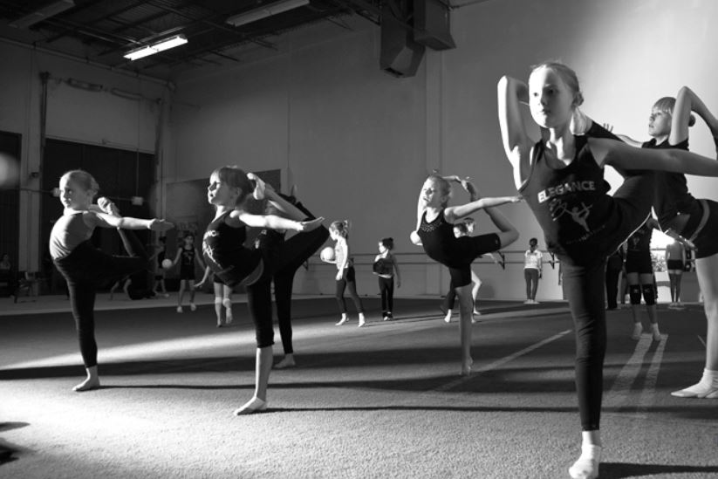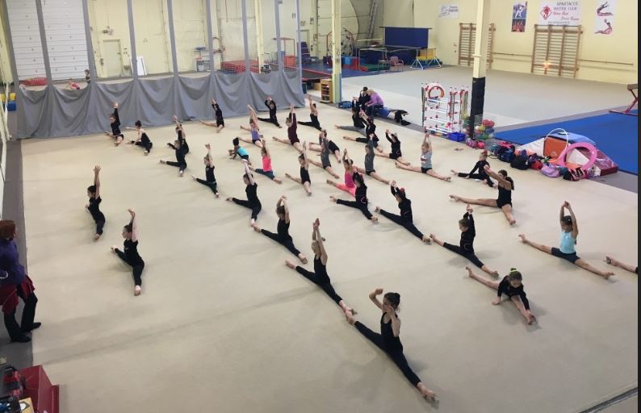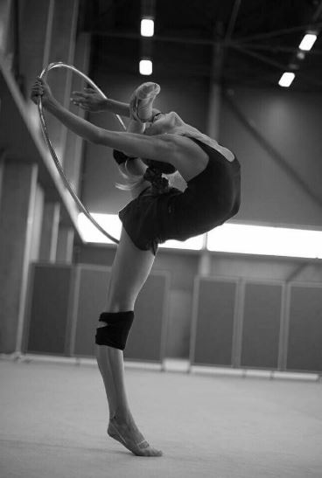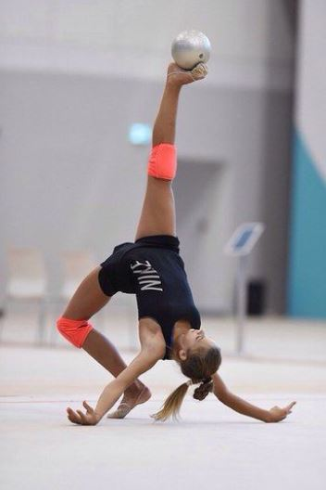

BC Rhythmic Gymnastics Sportive Federation
Return to Play Phase 3 update July 1st

BCRSGF Original Return to Sport (RTS) document was published on May 25, 2020 and was approved by the BCRSGF Board of Directors on May 24, 2020. The BCRSGF Return to Sport document has been updated multiple times since the original publication date.
The most recent update is June 1, 2021 guided by the Government of BC’s Restart Plan –Please note that these requirements may only be in place through the summer as the Government of BC is looking to progress to Step 4 of the Restart Plan as soon as
September 7, 2021.

As a part of Step 3 of the Government of BC Restart Plan, WorkSafeBC now requires that all businesses have their own Communicable Disease Plan instead of a COVID-19 Safety Plan. A template for BCRSGF member clubs to approve their own Communicable Disease Plan is on the BCRSGF website.

A large amount of BCRSGF’s previous requirements have been eliminated in this Restart Plan. Please review the entire document and begin transitioning from your club COVID-19 Safety Plan to a longer term Communicable Disease Plan.

• Information and graphics describing the BC Restart Plan are available here.
• viaSport’s Information and FAQs about the Sport Sector are available here.
Key Requirements and Changes for Indoor Sporting Activities as of July 1st, 2021 for Step 3 of the BC

Restart Plan Include:

• All clubs are required to develop and implement a Communicable Disease Plan instead of a COVID-19 Safety Plan. Each member club’s Board of Directors or Owner must approve the plan and the date of approval should be noted on the front page of the Plan. Communicable Disease Plans do not need to be publicly posted or shared with BCRSGF
• Interprovincial travel is allowed. International travel must follow federal restrictions and guidance.
• Physical distancing does not need to be maintained on or off the field of play.
• All spaces within facilities can be used – this includes change rooms, locker rooms, and Regular facility entries and exits can be used as well.
• There is no maximum group size (occupancy limit) for participants, coaches, volunteers, staff and officials.
• Spectators are allowed with a capacity of up to 50 or 50% of regular spectator capacity, whichever is greater.
• Socializing before and after sport activities is now acceptable.
• Hand sanitizing stations are no longer required but may be maintained as per your club’s
Communicable Disease Plan.
• Floor markings to direct traffic flow and physical distancing are no longer required but may be maintained.
• Contact tracing and screening requirements are no longer required. However, BCRSGF Member clubs should maintain attendance records.
• Masks are recommended for those 12 and over who have not received both COVID-19
immunizations when off the field of play.
• Consistent cleaning processes must be included in your club’s Communicable Disease

BCRSGF supports its member clubs to follow the restart philosophy from the BC Provincial Government. More specifically, this means that clubs are encouraged to carefully adjust their protocols like a dimmer switch, rather than completely changing all of their rules for operating overnight for their community and in their space.

• It is important to make sure that your members are safe;
• It is important to make sure that your members feel safe;
• It is important to be patient with individual differences as we all transition back to our normal lives. Some people may experience increased stress or anxiety with this transition;
• It is important that your club follows new requirements imposed by WorkSafeBC (e.g.,
the new Communicable Disease Plan).

In order to support the implementation of your club’s Communicable Disease Plan and to support your individuals’ members during this dynamic time, BCRSGF recommends that you undertake the following process:

1. Review the information in this document in detail and consider how significant the
changes are to your operations. Ask questions if you are unsure of what is required.
2. Plan how and when you will adjust your programming. Carefully consider the best ways to adjust programs, staff management, and engagement with your board, individual members and their parents.
3. Communicate with staff members, board, individual members and their parents to ensure that all groups are aware of the significant changes to programing at your club.
4. Implement the Communicable Disease Plan and lift COVID-19 requirements at your gym.

Clubs must create and implement a communicable disease plan that addresses the following six points:
- Implement policies to support staff who may be sick with a communicable disease (for example, fever and/or chills, recent onset of coughing, diarrhea), so they can avoid being at the workplace;
2. Promote hand hygiene by providing hand hygiene facilities with appropriate supplies and reminding employees through policies and signage to wash their hands regularly and to use appropriate hygiene practices;
3. Maintain a clean environment through routine cleaning processes;
4. Ensure building ventilation is properly maintained and functioning as designed;
5. Support employees in receiving vaccinations for vaccine-preventable conditions to
the extent that you are able;
6. Be prepared to implement additional prevention measures as required by a medical
health officer or the provincial health officer to deal with communicable diseases in
their workplace or region, should those be necessary.

Requirements
• Spectators are allowed with a capacity of up to 50 people or 50% of regular spectator capacity, whichever is greater.
• Masks are not required on the field of play. Masks are recommended for those 12 and
over who have not received both COVID-19 immunizations off the field of play.
• Consistent cleaning processes must be included in your club’s Communicable Disease Plan.

